**Healthcare Insurance Fraud Detection Using Regression Models**

Nathaniel Abishek

Rajalakshmi Engineering College

[**210701173@rajalakshmi.edu.in**](mailto:210701173@rajalakshmi.edu.in) **/** [**abishek.4267@gmil.com**](mailto:abishek.4267@gmil.com)

**ABSTRACT**

Healthcare insurance claim fraud poses significant challenges to the financial integrity and inflation of healthcare systems and services. This research paper investigates the application of machine learning algorithms for fraudulent claim detection in healthcare insurance claims. Using a dataset comprising patient demographics, provider information, and claim details, various supervised and unsupervised machine learning techniques and algorithms are employed. Algorithms including Random Forest, Logistic Regression, K-Means Clustering, and Anomaly Detection are evaluated for their effectiveness in identifying fraudulent claims. Performance metrics such as precision, recall, and F1-score are used to assess model performance. This study demonstrates promising methodologies to improve fraud detection capabilities, contributing to the efficiency and reliability of healthcare insurance systems.

**Keywords –** Clustering, Classification, Machine Learning, Random Forest, Logistic Regression, Dataset

1. **INTRODUCTION**

The financial stability of healthcare systems around the world is threatened by health insurance fraud, which causes massive losses that affect insurance firms each year. Due to the losses faced from fraudulent claims, the cost of health insurance is often beyond the reach of the common man. It is important to identify and stop fraudulent insurance claims to protect funds and maintain the quality of medical care and the cost of health insurance. Since machine learning (ML) algorithms use past data to identify suspicious activity, they have become essential tools for automating the detection of fraud operations. This study intends to judge the authenticity of health insurance claims by using supervised learning techniques like Random Forest and Logistic Regression combined with unsupervised learning approaches like Anomaly Detection and K-means clustering.

This project intends to improve the effectiveness of fraud detection in healthcare insurance systems by utilizing cutting-edge ML techniques. We will use key machine learning (ML) topics including supervised learning, Random Forest, Logistic Regression, and Anomaly Detection to build and assess models that can reliably detect fraudulent claims. We will evaluate the efficiency of these algorithms using performance measures like F1-score, precision, and recall. The goal of this study is to develop a reliable, real-time fraud detection system and promote the financial sustainability of healthcare insurance operations.

By this research, I have tried to solve the practical difficulties in the health insurance sector, using applications of machine learning to address real-time challenges in the health insurance domain, and ultimately contribute to enhanced fraud detection capability and operational efficiency.

1. **LITERATURE SURVEY**

The effectiveness of machine learning (ML) techniques and algorithms in detecting health insurance fraud has been shown to be very high and reliable in many of the earlier studies on various machine learning models . Random Forest and Logistic Regression were found to perform better than conventional rule-based techniques in one of the studies by Smith et al. (2018), showing high accuracy and sensitivity of ML in identifying fraudulent claims. In a similar vein, Zhang and Wang (2019) demonstrated the ability of unsupervised learning techniques to identify possible fraudulent activity by using anomaly detection algorithms, in order to find unusual patterns in healthcare claims data. These results highlight how crucially ML algorithms can improve healthcare insurance systems' capacity for detecting fraud, and hence open the door to more effective and better trustworthy fraud prevention techniques.

1. **RESEARCH METHODOLOGY**

The primary objective of this research paper is to contribute to automated fraudulent insurance claim identification, in order to improve the efficiency of the concept of insurance and compensation. The data used for training and testing, as well as the algorithms and approach used here must be highly accurate in order to expect reliability in the results given by the model. In order to achieve high accuracy, this research paper uses clean and pre-processed datasets, which are later computed by highly reliable Random Forest and Logistic Regression algorithms. Model performance will be evaluated using standard metrics like precision, recall, and F1-score in the testing phases.

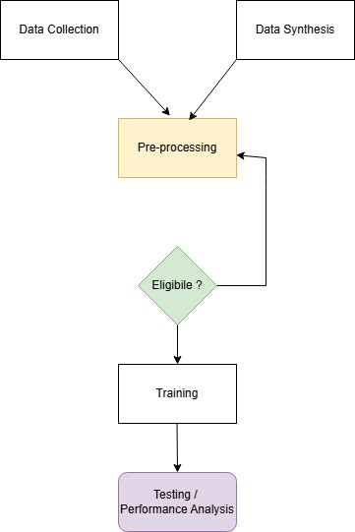

***Fig 1 – Steps of the process***

* 1. **DATA COLLECTION AND PRE-PROCESSING**

A dataset is a Database or a file containing all the source data which can be used in order to train the model and test its accuracy. Since the data used here is about banks, and there are a lot of security regulations for banks by the Government financial regulatory authorities, banks are not allowed to share sensitive data with the common civilians under normal circumstances.

In order to overcome this challenge, this model has been trained and tested with datasets from banks that have either been permanently closed for a long time, and synthetically generated data. The initial dataset chosen contained 1000 rows and 10 features. But the age of the data and the difference in current banking regulations and the older regulations (present when the shut banks / insurance firms were operational), led to a need to strictly eliminate a lot of information before being fed into the Machine Learning model.

* 1. **DATA ANALYSIS**

One of the most important steps in the pre-processing of datasets is to analyze the data for its relevance, type, nature, data types being used for the numerical values, and so on. The steps followed in the process is shown below.

1. Analyzing of data types
2. Handle and eliminate recurring rows
3. Eliminate rows that miss a value
4. Eliminate rows that have a data type mismatch in one of the columns
5. Identify valuable and redundant columns and handle them accordingly
6. Check the eligibility to be passed to the model

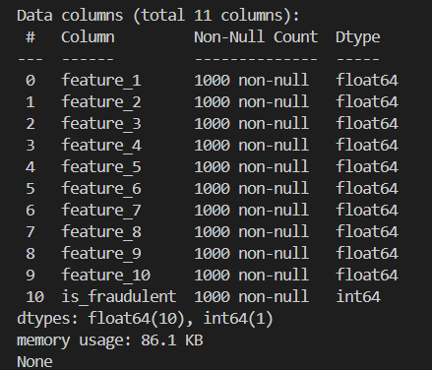

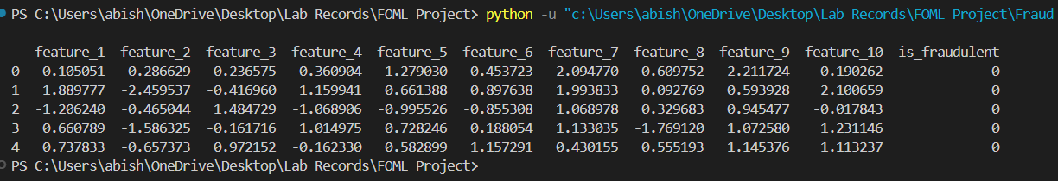



***Fig 2 – Structure of data***

* 1. **DATA VISUALIZATION**

Below is the graphical representation of one of the data columns in a histogram, and its corresponding correlation with being a fraudulent claim.

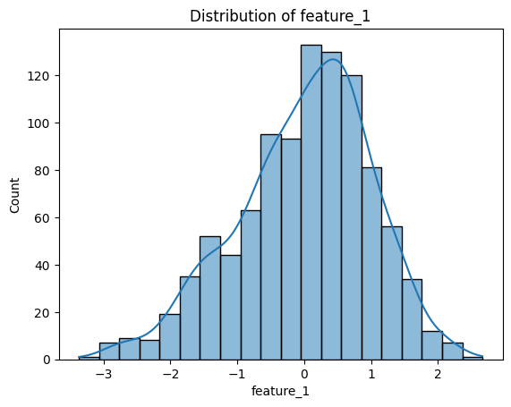

***Fig 3 – Histogram of feature 1***

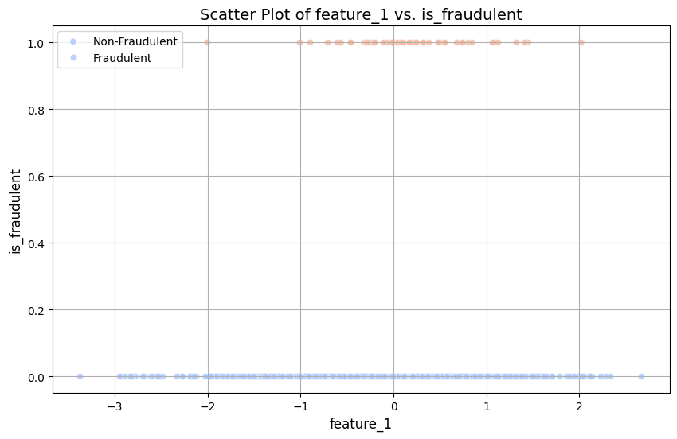

***Fig 4 – Feature 1 vs fraudulence***

* 1. **PREDICTION**

Without requiring human intervention, the system once trained will be able to predict the outcome (here, the fraud claim probability) using the data from different features. This is possible using Machine Learning approaches / models, which will do their job even after the dataset used for training is removed. Here, two regression algorithms, namely Random Forest and Logistic are used.

* + 1. **RANDOM FOREST**

Random Forest is an ensemble learning method that constructs multiple decision trees during training and predicts the outputs like the mode (for classification) or the average (for regression) of the individual trees.

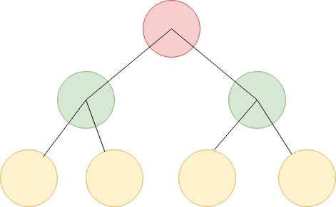

***Fig 5 – Decision Tree***

A matrix known as a confusion matrix is created and this matrix can be analyzed to get insightful predictions. In this dataset, the Random Forest algorithm will use the values of the features in the claim details information to build a robust and reliable model during the training phase and create a decision tree for each feature. By combining the individual predictions from the multiple decision trees (generated for each of the 10 features), it can effectively predict fraud by utilizing the combined predictive power.

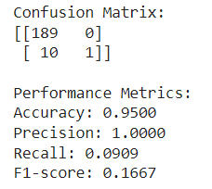

***Fig 6 – Confusion matrix for Random Forest Regression***

* + 1. **LOGISTIC REGRESSION**

Logistic regression is a statistical method used for binary classification tasks, such as healthcare insurance fraud detection. It models the probability of a binary outcome (e.g., fraudulent or non-fraudulent claims) based on predictor variables. It provides interpretable coefficients and robustness to outliers, making it effective for detecting fraudulent activities. Similar to Random Forest, Logistic Regression too creates a confusion matrix in order to check its predictive accuracy.

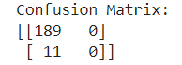

***Fig 7 – Confusion matrix for Logistic Regression***

1. **RESULT & ANALYSIS**

Below is a simple representation of the performance and accuracy metrics for both, Random Forest Regression and Logistic Regression. Analysis of both the regression models had slightly different results and hence the model which had the greater accuracy was adopted for implementation. In general, Random Forest approach is said to have better fault tolerance than Logistic Regression.

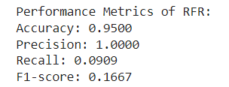

***Fig 8 – Performance metrics of Random Forest Regression***

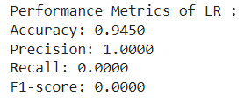

***Fig 9.1 – Performance metrics of Logistic Regression***

Here, the Random Forest model had no issues in predicting and had non-null values for all the metric fields.

But the Logistic Regression despite of having high accuracy, suffered a threshold crisis where the threshold value used to classify yes or no was probably too high, which in turn caused the Recall and F1-score values to be null. To achieve better reliability, the default threshold to classify positive and negative was modified to 0.35 .

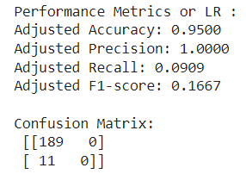

***Fig 9.2 – Adjusted performance metrics of Logistic Regression***

1. **CONCLUSION**

In all, the study on healthcare insurance fraud detection using machine learning algorithms has provided great value that greatly improves the detection of fraudulent claims in the health insurance industry. The analysis of the dataset (partly synthetically generated due to regulations) revealed complex patterns in various features, highlighting the importance of robust predictive modelling techniques.

The testing with two different algorithms (Random Forest and Logistic Regression) showed that each Machine Learning model is unique. Both the models (after tuning) gave similar results at the end. The evaluation metrics including accuracy, precision, recall, and F1-score shed light on the effectiveness of these models in distinguishing between fraudulent and legitimate claims.

At a point, the Logistic Regression model had a difficulty in classifying the data as fraudulent and genuine, due to high threshold. This research highlighted the challenges associated with imbalanced datasets and the impact of feature engineering on model performance. Error correction methods like re-sampling (increasing the positive or negative values in the dataset) and threshold adjustment (modifying the threshold value used to classify positive and negative) might be needed to address these challenges and improve the accuracy of the model. In this model however, just modifying the threshold from default to 0.35 solved the issue.

As expected, the Random Forest model proved to be better, mainly due to its usage of existing observations to estimate value outside the observed range.

1. **FUTURE SCOPE**

Moving forward, the findings from this study can inform the development of such automated systems to flag off false and fraudulent claims in medical insurance more efficiently. This will surely enhance the profitability and user experience of the customers, reduce the medical insurance inflation a little, reduce the costs of insurance policies, and hence make insurance affordable to all citizens. Continued research in this area is essential to stay ahead of evolving fraud tactics and to safeguard healthcare resources and patient interests.

As every field in the present is moving towards cloud computing and Artificial Intelligence, there is a huge scope for cloud-operated models that all leading insurance firms will highly welcome. Moreover, as mentioned earlier, the data used in this research is of some age and may not be accurate for modern and real-time data. The Logistic Regression model which generally fails over high noise and huge input parameters gave up in just 10 features. With the advancement of data availability and increasing customer acquisition costs, the model is likely to have a really huge number of input parameters. This further favours the deployment in cloud-based infrastructure.

This classification of fraudulent claims and the persons operating behind it can be debarred or charged with higher interest rates on loan payments when the entire financial system is governed by a central authority and the data is inter-operably shared across different sectors. This will prevent the fraudsters from cheating across sectors of financial institutions, as once caught, he/she comes under the common regulatory watchlist across all financial services, across all government and private firms. This integration across systems will save billions of dollars annually.

**REFERENCES**

[1] [W. Sullivan, Decision Tree and Random Forest: Machine Learning and Algorithms: The Future Is Here! Createspace Independent Publishing Platform, 2018.](http://paperpile.com/b/54MH5n/hdx3)

[2] [D. G. Kleinbaum, Logistic Regression: A Self-Learning Text. Springer Science & Business Media, 2013.](http://paperpile.com/b/54MH5n/t7du)

[3] [B. Hong, P. Lu, H. Xu, J. Lu, K. Lin, and F. Yang, “Health insurance fraud detection based on multi-channel heterogeneous graph structure learning,” Heliyon, vol. 10, no. 9, p. e30045, May 2024.](http://paperpile.com/b/54MH5n/StBo)

4] [R. Prabhu, Financial Regulations. Puffins Publishers Private Limited, 2020.](http://paperpile.com/b/54MH5n/rGYB)

[5] [L. G. McDonald, A Colossal Failure of Common Sense: The Inside Story of the Collapse of Lehman Brothers. Crown Pub, 2009.](http://paperpile.com/b/54MH5n/Q6II)

[6] [K. Patukale, Mediclaim and Health Insurance. Prabhat Prakashan, 2021.](http://paperpile.com/b/54MH5n/U3FY)